

**Faculty of Engineering and Technology**

**Department of Electrical and Computer Engineering Digital System**

**ENCS 234**

**Verilog project**

**\*\*\*\*\*\***

**Student’s Name: Maha Mali**

**ID: #1200746**

**Section: #2**

**Instructor: Dr.Mohammed Hussein**

Whole System Design

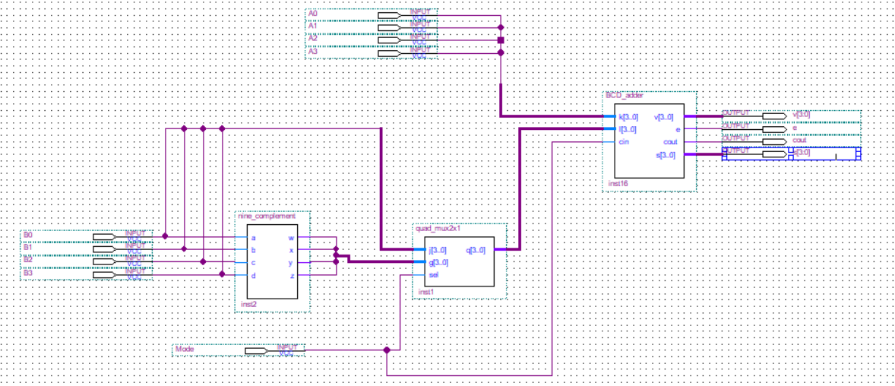

**Part A**

Design a combinational circuit that generates the 9’s complement of a BCD digit. Develop and simulate a **data flow model.**

**Code:**

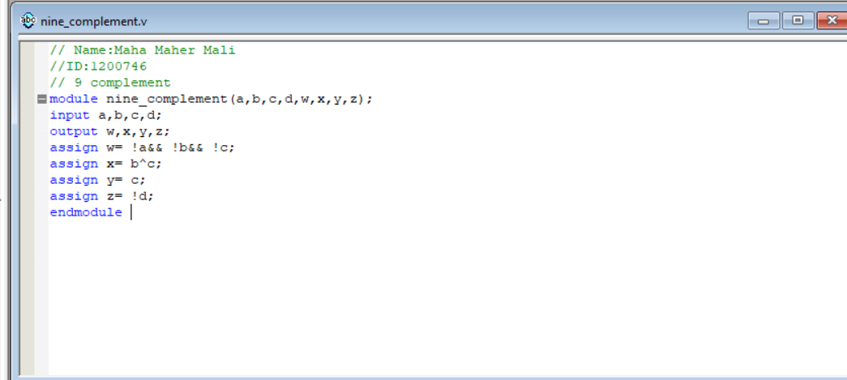

**Simulation:**

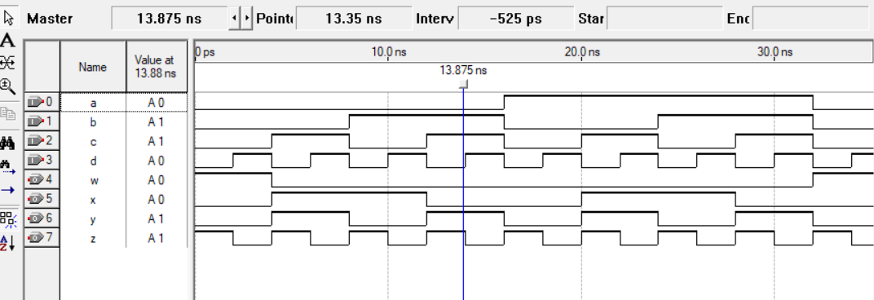

**Block Diagram**

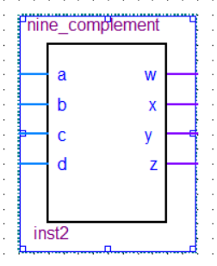

**Part B**

Design a combinational circuit that describes the quadruple 2X1 multiplexer using a **behavioral model.**

**code**

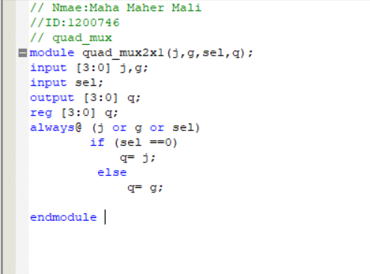

**Simulation:**

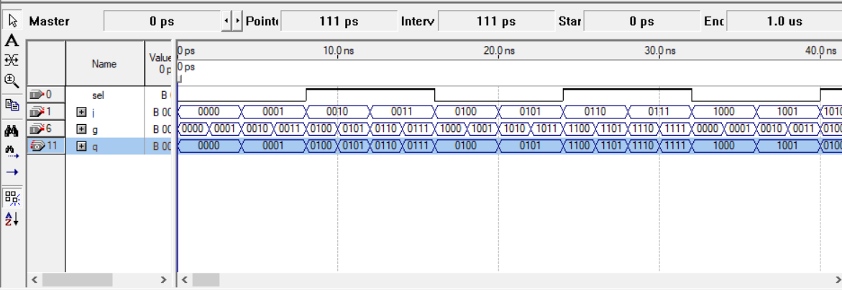

**Block Diagram**

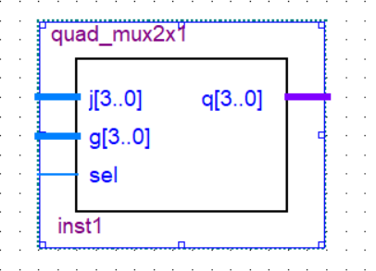

**Part c**

Design a combinational circuit for BCD adder in **data flow model.**

**code**

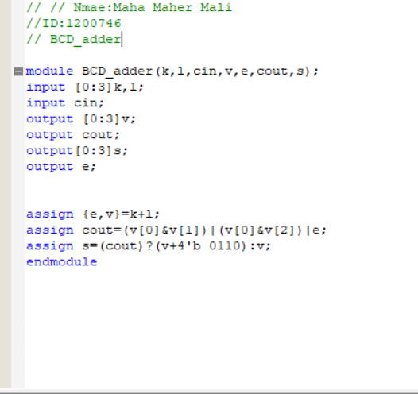

**Simulation:**

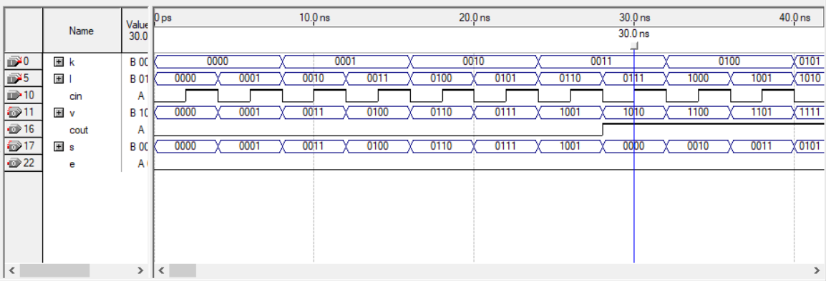

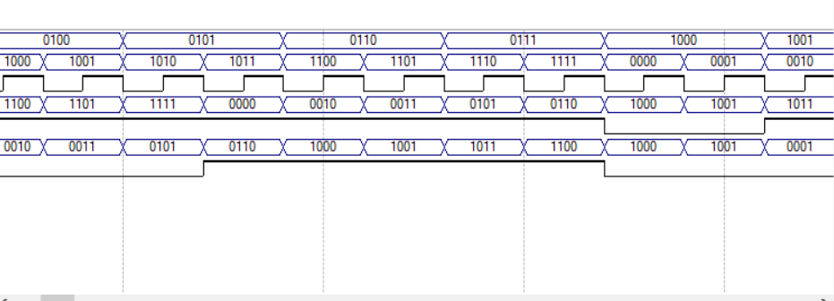

**Block Diagram**

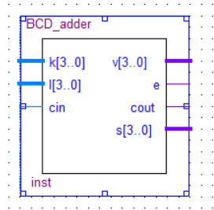

**Part D**

All the system components are to be instantiated in a top-level module using a **structural model.**

**code**

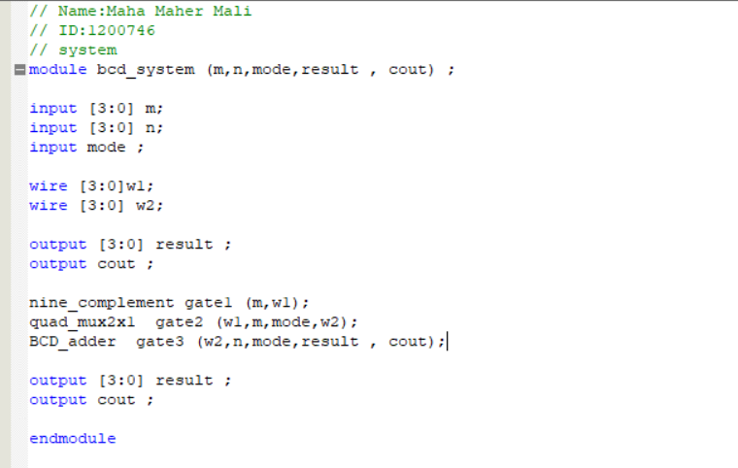

**Simulation:**

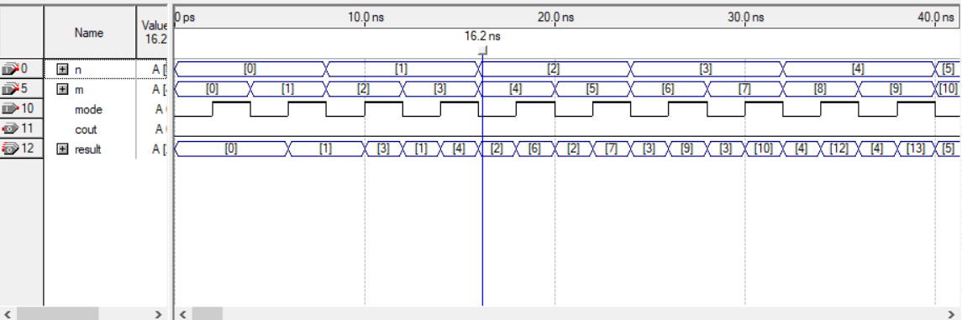

**Block Diagram**

